|  |  |
| --- | --- |
|  | **GST 113**  **NIGERIA PEOPLES & CULTURE** |
|  | Sarah AJIYA  Cordelia CLAYTON  Tobi JOHNSON  Dinatu B. TANKO  Felix ODOFIN  Cynthia M. SAIDU |

|  |
| --- |
| **[© 2019]** |
|  |



**LESSON 6**

**THE PEOPLE OF NORTHERN NIGERIA**

**Major Ethnic Groups of Northern Nigeria**

We can identify at least six (6) major ethnic groups in Northern Nigeria. These are the Hausa/Fulani, the Kanem-Bornu, the Nupe, the Igala, the Jukun and the TIV.

**THE HAUSA/FULANI PEOPLE**

The Hausa people represent one of the important and politically dominant groups in Northern Nigeria – predominantly in the North-Western part. By the year 2000, the Hausa population was estimated at about twenty million. They are also one of the largest linguistic groups in the whole of Africa. Hausa people are concentrated mainly in north-western Nigeria and in adjoining southern Niger republic. Hausa people are also found living in other countries of West Africa like Senegal, Cameroon, Togo, Chad, Benin, Burkina Faso, and Ghana.

Islam arrived in the area by the fourteenth century. By the fifteenth century, there were a number of independent Hausa city-states. They competed with each other for control of trade across the Sahara Desert, slaves, and natural resources. In the nineteenth century, the region was unified by a Fulani jihad (Islamic holy war) and became known as Hausaland. The British arrived and colonized the area in about 1900. Even during colonial times, the city-states and their leaders maintained some autonomy. Many Hausa traditions were preserved until late in the twentieth century.

Hausa folklore includes **tatsunya**— stories that usually have a moral. They involve animals, young men and maidens, and heroes and villains. Many include proverbs and riddles.  
Most Hausa are now devout Muslims who believe in Allah and in Muhammad as his prophet. They pray five times each day, read the Koran (holy scriptures), fast during the month of Ramadan, give alms to the poor, and aspire to make the pilgrimage (hajj) to the Muslim holy land in Mecca. Islam affects nearly all aspects of Hausa behavior, including dress, art, housing, rites of passage, and laws. In the rural areas, there are communities of peoples who do not follow Islam. These people are called Maguzawa. They worship nature spirits known as bori or iskoki.

**Origins of the Hausa**

Like major ethnic groups in Nigeria, the origin of the Hausa people is not very certain.

**Bayajida Version**

Most scholars agree that the Bayajida story is the most authentic oral tradition in Hausaland that attempts to explain the origin of the Hausa states. According to the legend, Bayajida is believed to be the founder/hero of the Hausa states. He is also believed to have come from Baghdad, Iraq in the Middle East.

According to tradition, Bayajidda (Abu Yazid), the mythical ancestor of the Hausa, migrated from Baghdad in the ninth or tenth century AD. After stopping at the kingdom of Kanem-Bornu, Bayajida married the daughter of the Mai of Bornu by whom he had a son at Biran. He later fled Biran when he discovered that the Mai of Bornu planned on killing him due to his growing popularity and influence in the land, he moved west to Daura where he helped the people of Daura kill a dangerous snake, which had for a long time prevented the people from taking water from a well. According to the legend, the Queen of Daura (Magajiya) was very impressed and decided to marry him. They bore a son named Bawo who later founded the city of Biram. Bawo had six sons who became the rulers of other Hausa city-states: Biram, Bagauda (Kano), Gunguma or Zazzau – (now Zaria), Duma (Gobir), Kumayo (Katsina), Zamma (Rano) and Gazora (Daura). Collectively, these are known as the Hausa bakwai (Hausa seven).

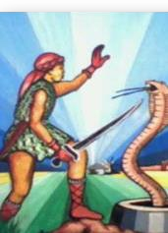

**THE SOCIO-POLITICAL ORGANIZATION OF THE HAUSA**

The Sarki has always been known as the head of any typical Hausa state. He always works with a retinue of officials in a well-organized court. The Sarki of a Birni (city) was very significant. His full title was Sarkin Kasar, which means “ruler of the land” and not just city. The Sarkin Kasar combined both political and religious/spiritual functions. He was also the chief executive and judge of the state, but he was aided by a council of state. At the district level, the government was modeled after that at the national level. Also know that between 14th and 15th centuries, the socio-political organization of Hausa States took another shape. For instance, Islam was adopted and this gave birth to new political institutions such as the offices of the Galadima (senior counselor), Madawaki (palace administrator), Magaji (overseer), Dogari (guard), Zagi (orderly), Yari Sarki and Sarki Yau. The Islamization of Hausaland also influenced its judicial system. The Sharia law started taking shape. Some new titles and concept such as Alkali or the Qadi (judge), Zakat (income tax), Jangali (livestock tax) became commonplace in the administration.

**THE FULANI**

The Fulani ethnic group in Nigeria lives side-by-side with the Hausa and others particularly in the Northern region of Nigeria. The Fulani ethnic group is largely nomadic. They are believed to have originated from the Futa Jalon highland region of West Africa from where they migrated in stages to various places in the West African sub-region.

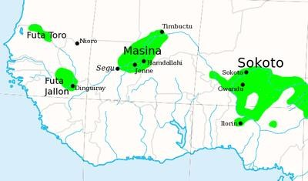

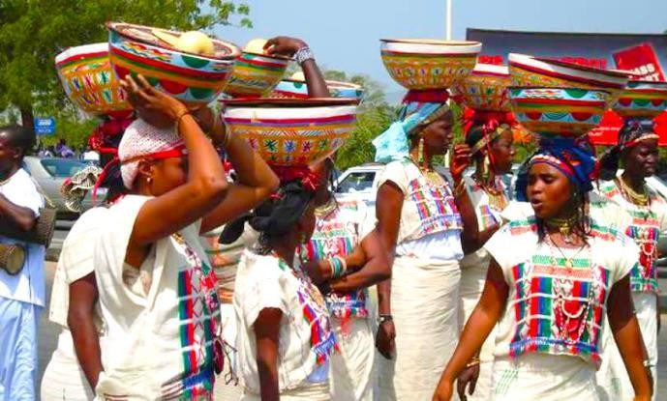

The Fulanis are described differently as follows: “Peul” by the Wolof, “Fula” by the Bambara, “Fellata” by the Kanuri and are generally called Fulani by other Nigerians. The Fulani call themselves “Fulbe”. They profess Islam while others maintain syncretic practice and their main occupational activity is cattle-rearing by the males and cow-milking by the females. The Fulanis are of two categories, namely: fulanin daji (nomadic or pastoral) fulani and fulanin gida (sedentary or home/town) Fulani.

The Fulani are widely distributed in West Africa most especially in the Sahel, wandering from one spot to another with their herds of cattle. In fact, they are found in almost every country of the Sudan zone of West Africa extending from the Senegal area in the West to the Upper Nile in the east. The pastoral Fulani’s life is principally basic and simple. They strive to maintain their tradition and culture wherever they go. They generally adhere to a code of behaviour referred to as “pulaaku” which suggests they must exhibit the following qualities: shiness, bravery, ownership of cows etc. In the pre-colonial period, the Fulani, under Shehu Usman Danfodiyo’s leadership, were able to revive Islam in most parts of the Hausaland. Following the Jihad, (an aggressive campaign for an idea) they functioned basically as administrators and sometimes as cultivators. As devout Muslims, they were very instrumental in assisting Shehu Usman Danfodiyo in the execution of the popular Sokoto Jihad which helped in the socio-political as well as the religious changes of Northern Nigeria in the course of the nineteenth century.

**THE KANEM-BORNU (KANURI) PEOPLE**

**Origin of the Kanem-Bornu People**

Kanem-Bornu ethnic group also has many versions of its origin. But all these versions are not certain. They are also known to have been exaggerated in the region North East of the Lake Chad. Kanuri is the language that unites all the Kanem-Bornu people.

**The “SO” Version**

Some scholars argue that the “So” (Kanuri) people were the first settlers in Kanem- Bornu. According to them, the “So” had developed a sophisticated socio-political culture based on agriculture and the knowledge and use of iron technology. This happened long before the Zaghawa who later invaded the land.

**The Saif Bin Dhi Yazan Version**

There is another tradition of the history of Kanem-Bornu, which attributes the foundation of

Kanem-Bornu to the great Arab hero, Saif bin Dhi Yazan of Himyar. This happened between 9th & 10th centuries A.D. Yazan is also credited to have established the now famous Saifawa dynasty. Know that the Saifawa dynasty was one of the longest ruling dynasties in the pre-colonial West African Sub-region.

**THE SOCIO-POLITICAL ORGANIZATION OF THE KANEM-BORNU**

It is very important to notice that the nucleus of the socio-political organization of the Kanem Bornu people was based on kinship. For instance, the Mai (king) was the highest authority in the political structure. His mother i.e. the Queen Mother (Magira) was a very important and respected personage in the Kanem political structure as well. The King’s sister (Mogaram) was also very important. She was to assist the King in the day-to-day administration of Kanem.

**The “Nokena”**

Besides the kinship oriented political system of the Kanem people, there was an imperial state council known as the council of the twelve, or the “Nokena”. The principal duty of the “Nokena” was to offer the king useful advice.

**The Maini Kanendi or Khadi**

The Maini Kanendi (Khadi) was the chief judge of the State. He played a major role in the Kanem political structure. By his position, he was the Mai’s legal adviser as well.

**The Army**

In the traditional Kanem-Bornu, the army played a vital role in the administration. The army was very professional. It was divided strategically into two divisions: a home division and a bush garrison.

**The Titled Nobility**

The titled nobility was another institution within the Kanem-Bornu political structure. They are known to have exercised tremendous influence in the state and were assigned fiefdoms to administer. The most important of these were Galadima (governor of the western province), Kaigama (commander of the army), Yerima (governor of Yeri province) and Meshema or Mustrema (queen mother’s representative fief).

**The Servile Institution**

The servile was made of slaves and eunuchs. They are known to be important in the administration of the state. They also held offices like “Mushemu”, “Yuroma” and Kachalla”.

